Technology Stack (Architecture & Stack)

Parameter | Details
Date | 18 June 2026
Team ID
Project Name | Book A Doctor
Maximum Marks | 4 Marks

____________________________________________________

Technical Architecture:
The Deliverable shall include the architectural diagram as below and the information as per the table 1 & table 2

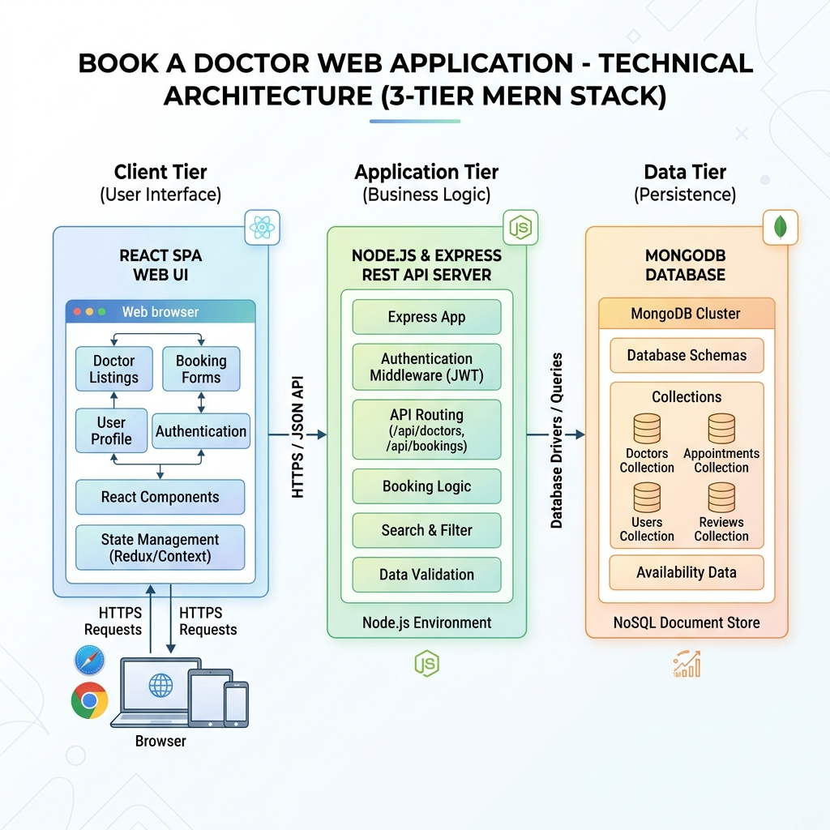
Technical Architecture Diagram

Table-1 : Components & Technologies:

S.No | Component | Description | Technology
1 | User Interface | Web client interfaces for Patients, Doctors, and Admins to log in, search, and book. | HTML5, CSS3, JavaScript (React.js, React Router, Vite)
2 | Application Logic-1 | Core API logic, router paths, middleware handlers. | Node.js, Express.js
3 | Application Logic-2 | JWT role-based access verification middleware. | jsonwebtoken package
4 | Application Logic-3 | Encryption logic for password hashing. | bcryptjs package
5 | Database | Core data persistence for accounts, appointments, profiles. | MongoDB, Mongoose ODM
6 | Cloud Database | Database hosting and management service. | MongoDB Atlas cloud clusters
7 | File Storage | Uploaded medical files (PDFs/Images). | Local directory writes via Multer middleware
8 | External API-1 | Direct static asset routes serving. | Express static routing path /uploads
9 | External API-2 | Verification and admin approvals route logic. | Express PUT controller endpoints
10 | Machine Learning Model | Optional diagnostic or recommendation models integration. | Local backend API interfaces
11 | Infrastructure (Server / Cloud) | Windows development system environment setup. Port 5000 (server) and 5173 (client). | Node.js local environment host execution

Table-2: Application Characteristics:

